Harbalbh Singh A00174250, Yuvraj Singh A00172517, Namanjot Kaur A00172920, Jaspal Singh A00172058, Surinderpal Singh A00171345, Sukhchain Singh A00171060, Sagar Badsar A00170280

Lab-3 Web programming

To- Prof. Disha Grag

Lab-3 Our College,

1. Landing Page,



2. Programs/Courses,





3. Get Started,



4. Experience,5. Support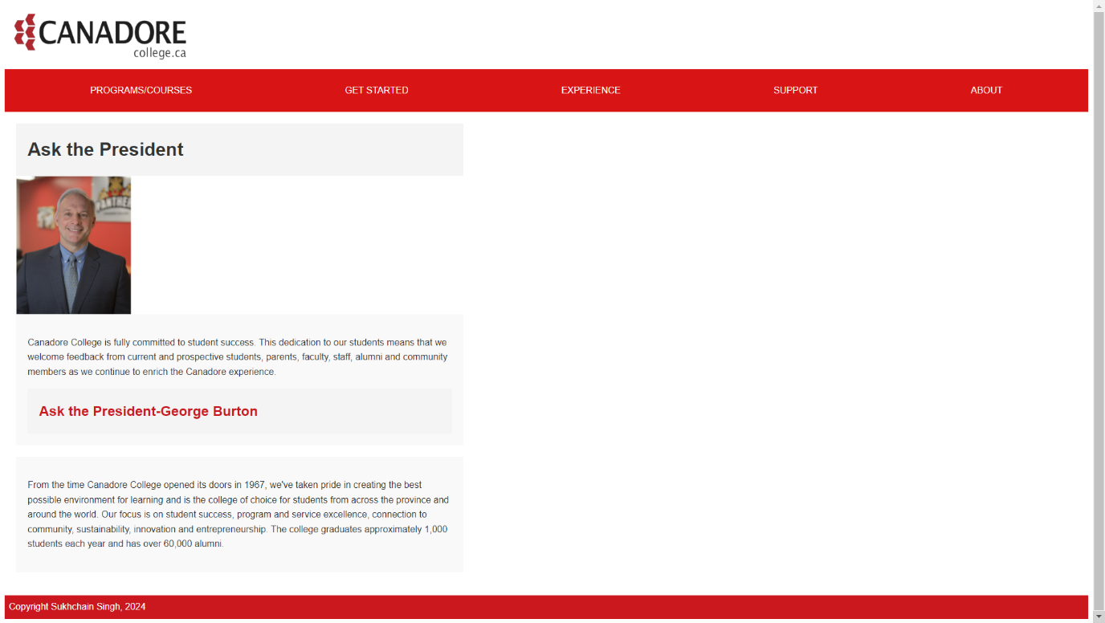

6.Corporate,





7.About,

